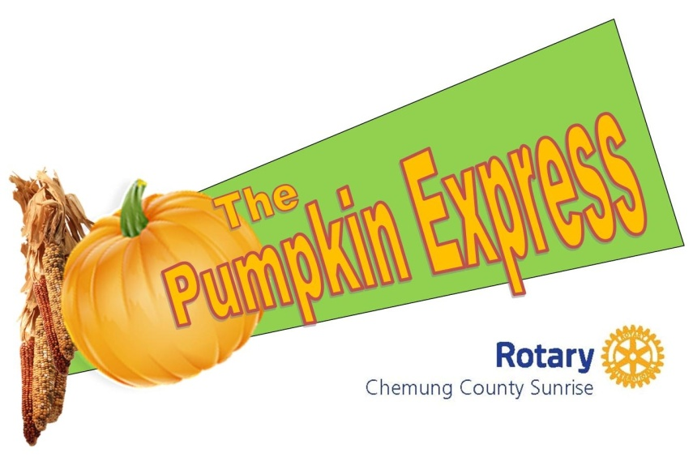

On Saturday, October 8, 2022 the Chemung County Sunrise Rotary Club and the Sullivan family will host the seventh annual Pumpkin Express Festival. This exciting family event will be held from 12 – 4 p.m. at Sullivan’s Railroad on Old Ithaca Road in Horseheads and will feature food, music, pumpkin decorating, as well as other fun family activities and of course, FREE TRAIN RIDES.

We are looking for vendors who sell family friendly products to join us. We will provide you with a 12’ x 12’ space to display and sell your products. You must bring your own tent. Setup for the event will begin at 9:30 a.m. and should be completed by 11:30. There is a $35 entrance fee.

All proceeds from the Pumpkin Express Festival will aid in our Sunrise Rotary Club’s continued financial support to local programs such as Camp Star, Meals on Wheels, The Potters’s Hands Foundation, Polio Plus and many others. We also offer a scholarship to anyone interested in pursuing a trade, whether you are just starting your career or have decided to pursue a different career later in life. In addition, we support the reading program in the Elmira School district. In 2014 we provided eight park benches to the Age Friendly Program in Chemung County. These benches were placed strategically in our community’s parks and trails for all to enjoy.

We hope you will join us in making the 7th Annual Pumpkin Express Festival a memorable and successful one. Please feel free to contact Jackie Stevens at (607)739-4960 or by email at jackieshortarms@hotmail.com with any questions you may have.

Sincerely,

Chemung County Sunrise Rotary Club
Pumpkin Express Festival Committee

PUMPKIN EXPRESS FESTIVAL
Saturday October 8, 2022
Sullivan’s Train Yard
Ithaca Road. Horseheads
12 p.m. – 4:00pm

VENDOR REGISTRATION INFORMATION

For More Information call 607-739-4960
OR EMAIL: jackieshortarms@hotmail.com
Website – www.chemungsunriserotary1989.org

VENDORS

- Spaces are 12’ x 12’ If your tent is over this size or you need more space you must purchase the appropriate amount of spaces!
- These are non electric spaces. No electricity will be provided to vendors, including food vendors. If you require electric you will need to bring your own generator.
- The spaces are assigned in order of receipt of entry fee, applications and all other necessary paperwork.
- You may use NON ELECTRIC HEATERS, provided they have a fire extinguisher present at check in and at the booth at all times.
- Vendors should provide their own tables and overhead cover.
- Please indicate if you have a tent or trailer that will be set up or parked in your space(s).

GENERAL DIRECTIONS FOR ALL PARTICIPANTS

** FIREWORKS, POP SNAPS OR OTHER SIMILAR ITEMS ARE NOT ALLOWED! If a vendor is caught selling, or giving them out they will be asked to leave and will not be allowed to participate in further festivals**
- Set up begins at 9:30am and must be completed by 11:30am
- Removal of booths and displays begins at 4:00pm – NO EXCEPTIONS PLEASE!
- We ask that you police your area during the event and clean-up debris before you leave.
- Vendors are placed with consideration for competing goods. Our festival is designed for entertainment stages and special features to draw attention in every direction.

Please makes checks payable to Chemung County Sunrise Rotary. Mail your application, check or money order, copy of sales tax certificate, to the address on the application form. Upon receipt of these items, you will receive a confirmation email confirming your space. No refunds will be given to confirmed vendors who choose not to show. * A twenty-five ($25.00) fee will be assessed for returned checks.

PLEASE NOTE:
- The above procedures are required to conform with the Town of Horseheads Law. We appreciate your cooperation.
- The event will be held rain or shine.
- Sales tax in Chemung Co. is 8% and collection of the tax is the sole responsibility of the selling vendor.
- Chemung County Sunrise Rotary reserves the right to take photographs / videos for publicity
- Chemung County Sunrise Rotary will not be held liable for any loss to participants’ property.
- Please call 607-739-4960 or email jackieshortarms@hotmail.com if you need additional information.

We look forward to the 5th annual Pumpkin Express Festival and thank you for your participation.
ALL PROCEEDS FROM PUMPKIN EXPRESS FESTIVAL WILL BENEFIT ROTARY PRO
PRICING (Payment & App Received by October 10th)

1st space - $35.00
2nd space - $60.00
3rd space - $85.00
All multiple spaces must be next to each other
PUMPKIN EXPRESS FESTIVAL
VENDOR REGISTRATION FORM 2022

Business Name______________________________________________________________________
New York State Tax ID ______________________________________________________________
Contact Person_____________________________________________________________________
Address___________________________________________________________________________
City, State, Zip Code_________________________________________________________________ E-Mail (for registration confirmation)____________________________________________________
Day Phone___________________________ Evening Phone__________________________

Brief description of items you will sell:____________________________________________
__________________________________________________________________________________

# Spaces Needed______ Amount enclosed______________

Are you bringing a generator? Y or N

Are you bringing a NON ELECTRIC heater? (Fire extinguisher is required) Y or N

You will bring: Trailer____________ Dimensions: ________ by _____________

Tent__________ Tables only_______________

- NO ELECTRIC HEATERS MAY BE USED

- Fire extinguishers are REQUIRED for NON ELECTRIC HEATERS

Please return this application with check or money order payable to Chemung County Sunrise Rotary.
Include a copy of all applicable permits, NYS SALES Tax Id as necessary to:

Pumpkin Express Festival
Chemung Sunrise Rotary
PO Box 334
Horseheads, NY 14845

For more information call 607-739-4960

NO SPACES WILL BE RESERVED OR ASSIGNED UNTIL ALL PAPERWORK IS RECEIVED

DO NOT WRITE BELOW LINE For Business Purpose only

________ Fee received _________Tax ID Space Assigned ___________________

